**Today – Lab Experiment (20/8/2020)**

1. Finish your experiment and show the output at 3pm and upload in GCR)

|  |  |  |
| --- | --- | --- |
| **Login-Exp2**  (5 marks)  Viva-(html5 tag, and css3.0) | **Regsitration-Exp3**  (5-marks)  Viva (html5 tag, and css3.0) | Total  (10) |
|  |  |  |

Apply css3.0 and HTML5 with proper validation in experiment3 and experiment4.

**Experiment3**- Login page – Use Box Model (border, padding,background ,image (left side),background image with possible repeat property,animation)

Sample design for exp3 and 4

- 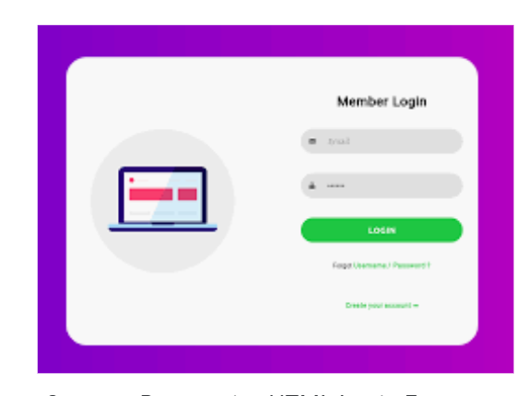

**Experiment4**: Registration form

Include the following in your form.

1. fieldset for Personal information and college information
2. DOB- date picker
3. College and course details, website url address .

